**Embedded System Software Design Project 1**

M10907324吳俊逸

⚫ Part 1 [Global Scheduling. 10%]

▪ Describe how to implement Global scheduling by using pthread. 5%

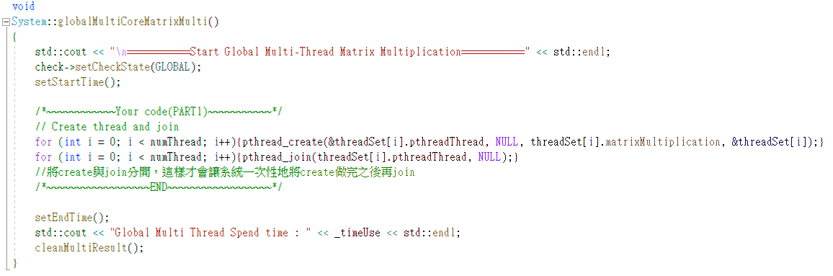

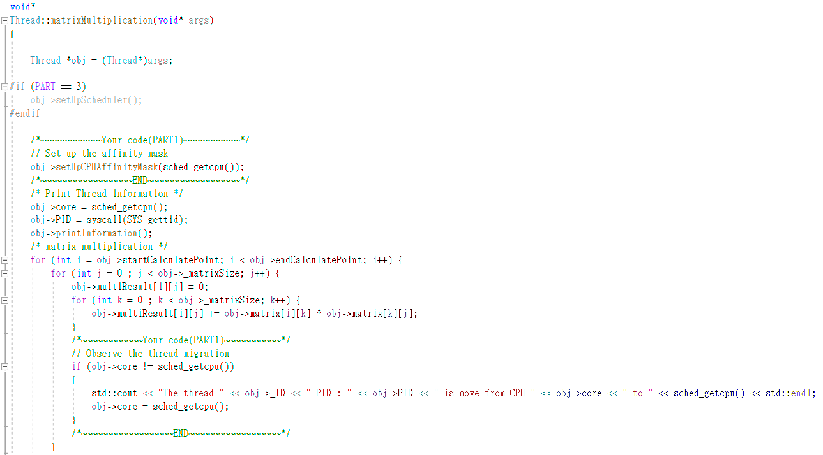

▪ Describe how to observe task migration. 5%

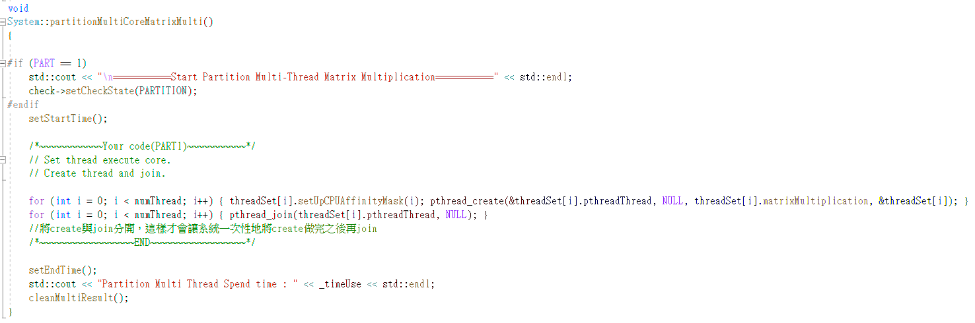

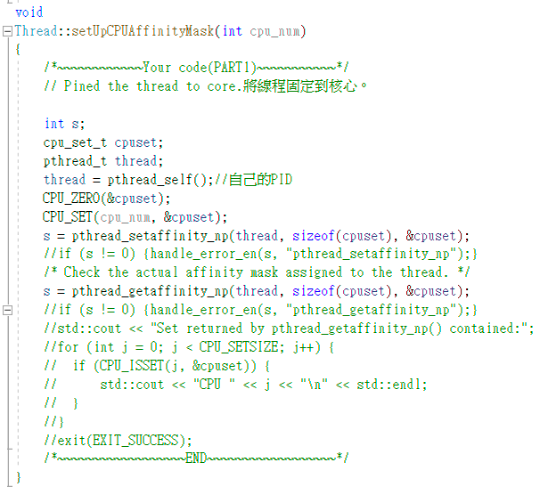

[Partition Scheduling. 5%]

▪ Describe how to implement partition scheduling by using pthread.

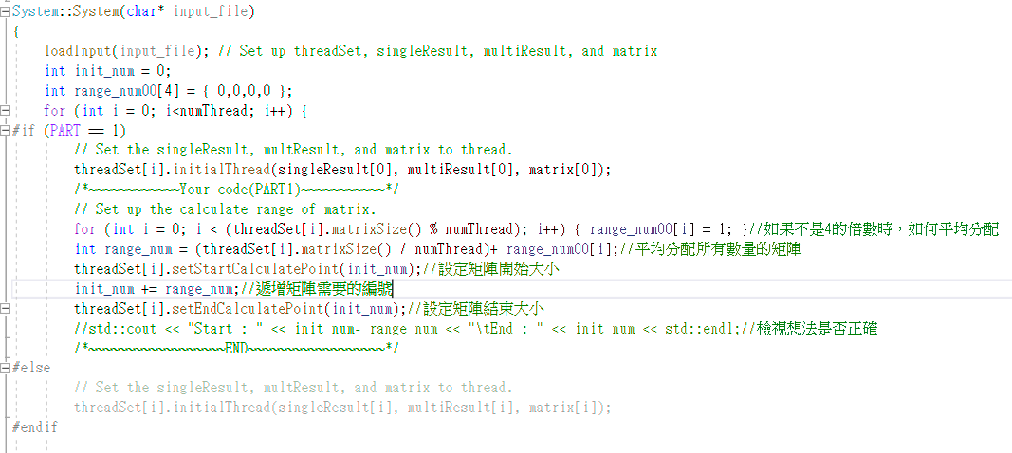

[Result. 10%]

▪ Show the scheduling states of tasks. (You have to show the screenshot result of using the input part1_Input.txt)

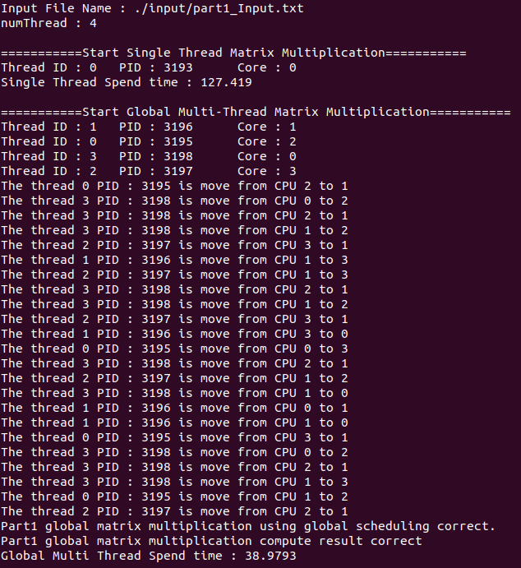

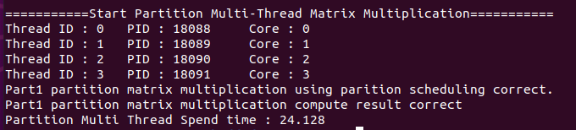

⚫ Part 2 [Partition method Implementation. 10%]

▪ Describe how to implement the three different partition methods (First-Fit, Best-Fit, Worst-Fit) in partition scheduling. [Result. 30%]

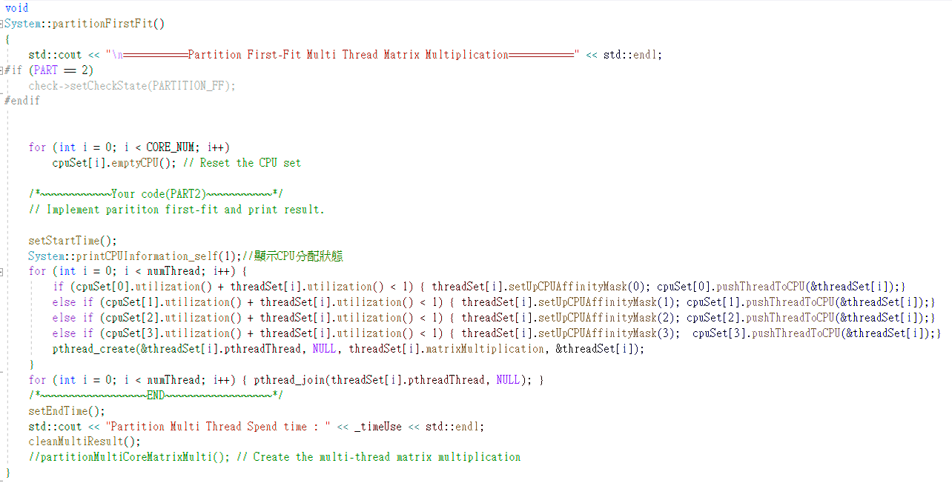

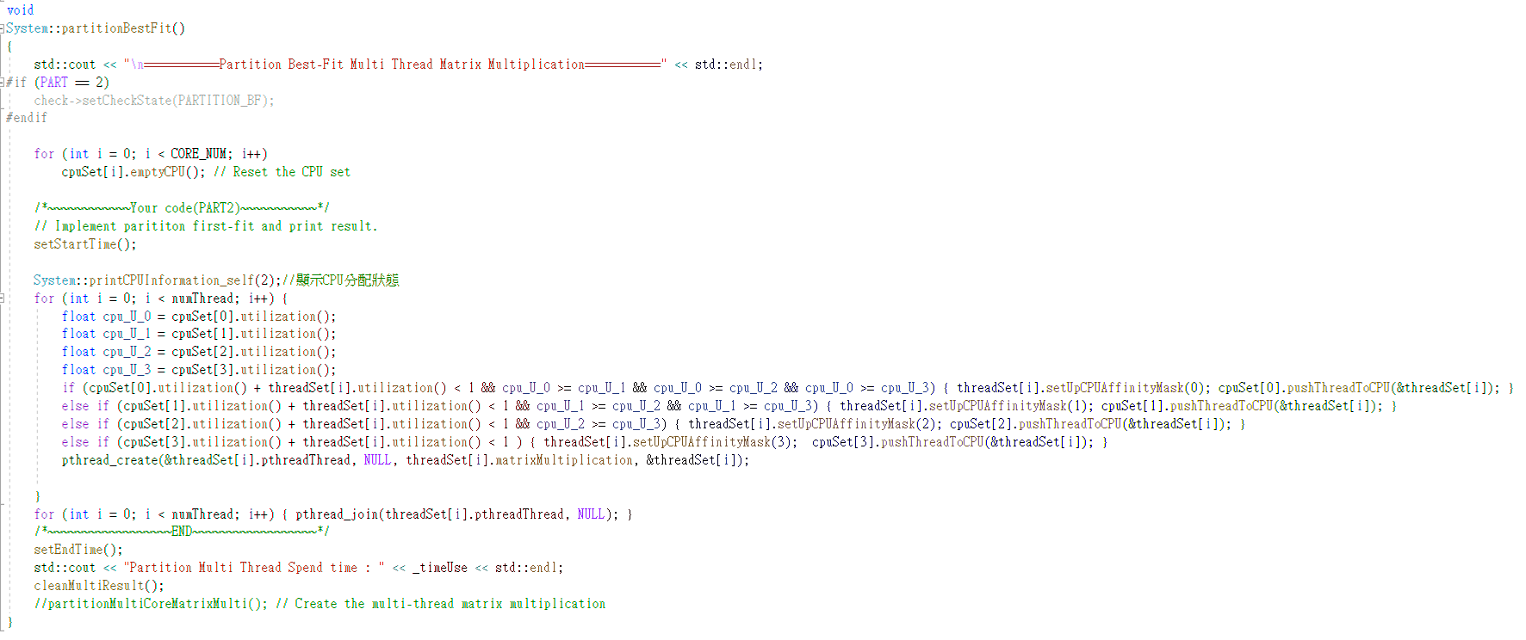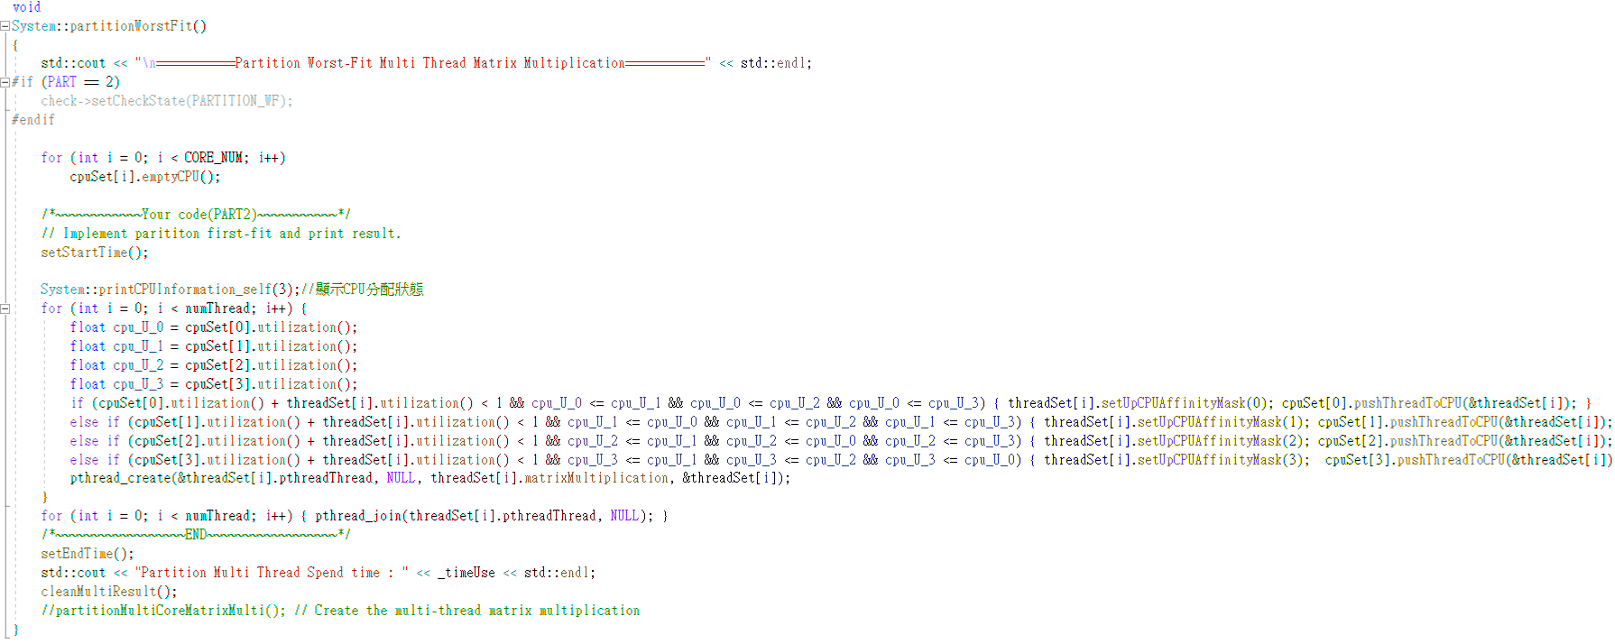

▪ Show the scheduling states of tasks. (You have to show the screenshot result of using input part2_Input_10.txt and part2_Input_20.txt)

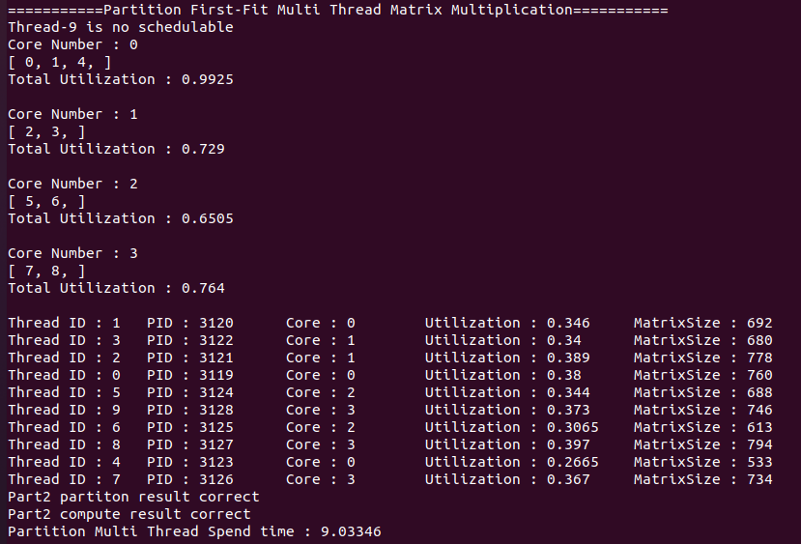

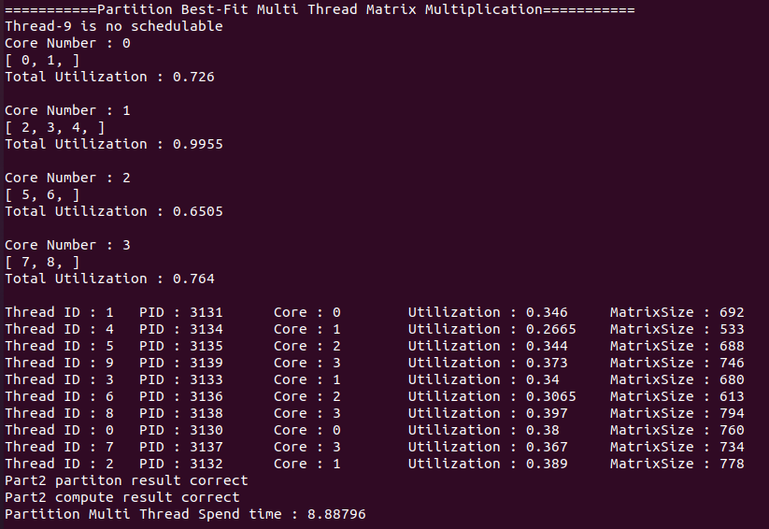

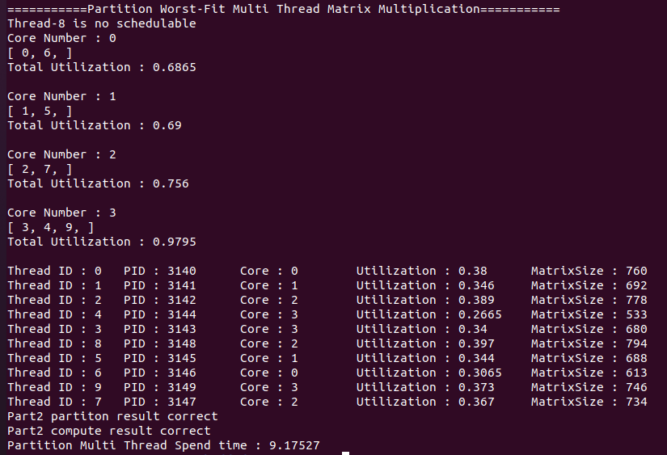

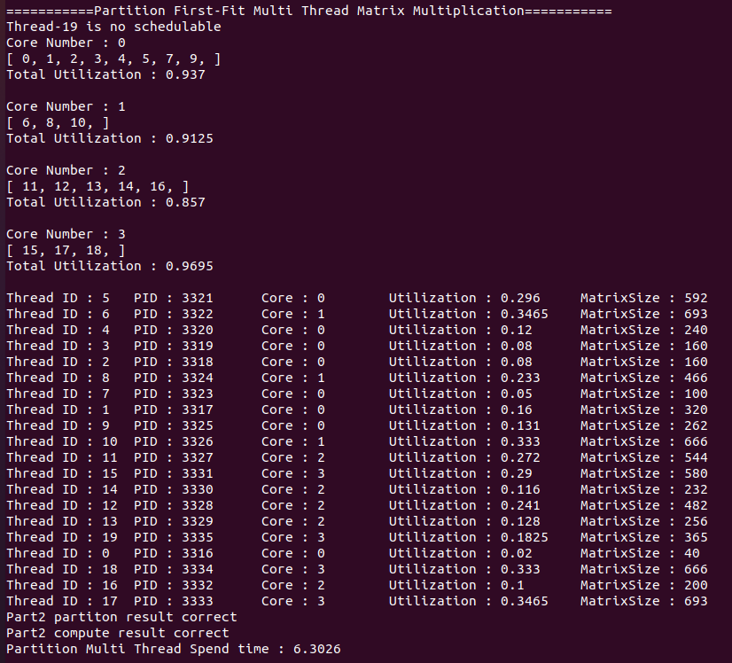

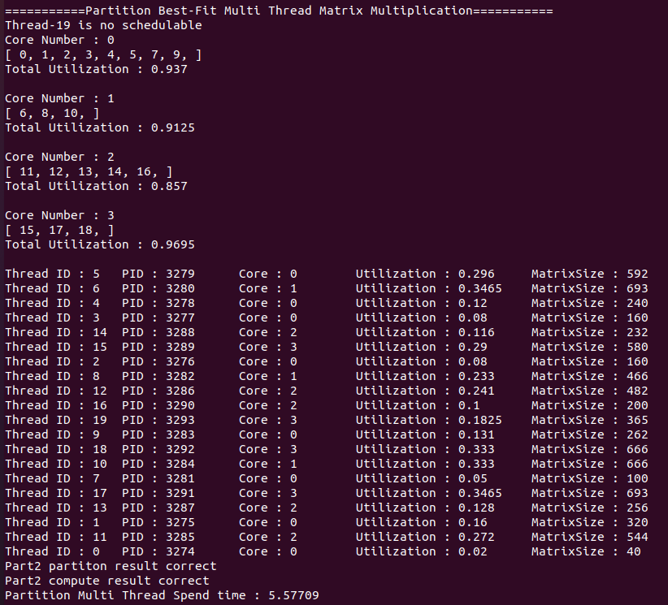

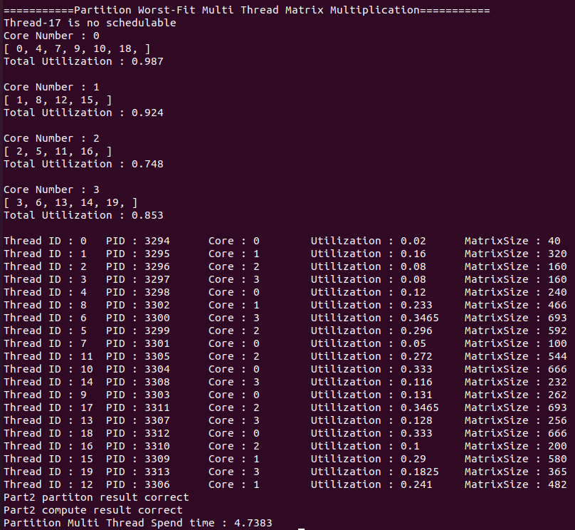

⚫ Part 3 [Scheduler Implementation. 10%]

▪ Describe how to implement the scheduler setting in partition scheduling. (FIFO with FF, RR with FF) [Result. 10%]

▪ Show the process execution states of tasks. (You have to show the screenshot result of using input part3_Input.txt)

⚫ Discussion

▪ Analyze and compare the response time of the program, with single thread and multi-thread using in part1 and part2. (Including Single, Global, FirstFit, Best-Fit, Worst-Fit) 10%

▪ Analyze and compare the response time of the program, with two different schedulers. (FIFO with FF, RR with FF) 5%